Call for Papers and Registration for ICEQ & INCLUDE Student Voice Conference:
Thursday 8th of April 2021, 10:00 – 18:00 MST
You are invited to the inaugural online Student Voice Conference: Student Agency and Wellness in the Remote Environment hosted by The International Collaboratory for Leadership in Universally Designed Education (INCLUDE) and the International Conference on Education Quality (ICEQ).

The conference aims to reveal and share how learners make positive changes in their learning environments. Additionally, the conference seeks to provide a platform for students to share their thoughts and experiences on the challenges they have faced, and the strategies they have used to access learning during the Covid-19 Pandemic which caused a global move to remote, online and blended learning environments in Higher Education.

Conference Themes:
- Addressing wellness and academic challenges to students
- Addressing the importance of student agency and involvement in policy making and curriculum design
- The challenges but equally the opportunities posed and offered by the current situation of the new normal to activate student agency

Keynote Speakers

Professor Abdelaziz Bendou, President of Ibn Zohr University, Agadir, Morocco

Professor Bendou is President of Ibn Zohr University, Agadir- Morocco. He started his university career in the field of Energy and Systems Modelling. He has acted as Vice-Dean of the School of Engineering, Dean of the Business School, University Vice-President for Scientific Research. Professor Bendou has also directed a number of faculty, course and student development cooperation research projects such as « Métiers du conseil » under the Tempus Meda programme; Erasmus Mundus Partnerships Project; University Network for Business and Administration; Erasmus Plus Project, INSTART- “Euro- African Network of Excellence for Entrepreneurship and Innovation”.

Professor Sarah Greer, Provost and Deputy Vice Chancellor, University of Worcester, UK

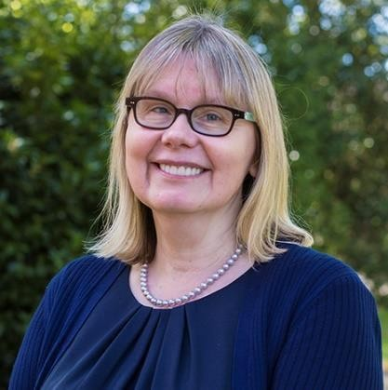
Professor Sarah Greer is the Deputy Vice Chancellor and Provost of the University of Worcester. A former barrister, Sarah has held a range of leadership and academic roles across universities, private and public sector organisations. Sarah is a National Teaching Fellow of the Higher Education Academy and continues to publish on a range of legal areas. She has also held a number of public appointments in England and Wales, including most recently as a General Commissioner for the Disabled Students' Commission.

Ms Luigia Nicholas, Student at Stellenbosch University, Western Cape, South Africa
Luigia Nicholas is a Postgraduate Tax Law Candidate at Stellenbosch University (StU) in the Western Cape, South Africa. She completed her Bachelors of Commerce degree in Business Management at (StU) in 2019. She is a Steering Group Member for INCLUDE. She is the Deputy Chairperson of the National Disabilities Sub-Committee a division of the South African Union of Students and the Special Needs Manager on the Student Representatives Council at StU. She is a student assistant and student mentor at the Disability Unit in the Centre for Student Counselling and Development at StU. In 2020, she received a South Africa 100 Shining Star Award from ‘Inside Education’ and a Rector’s Award for Excellence in Social Impact from StU for her work in disability awareness.

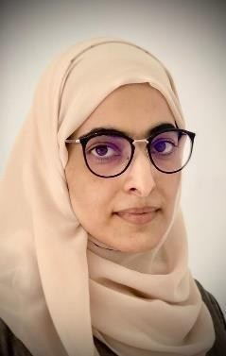
Ms Zainab Al Shidhani, Student at the University of Houston, Texas, USA

Zainab is a student in the PhD program in Curriculum and Instruction at the University of Houston, USA. She worked as a teaching assistant and then as a lecturer in Educational Technology at the Sultan Qaboos, Oman University since 2009.

Through her academic journey, she participated in different student and professional committees and organizations. Recently, she won the award of outstanding practice by a student in Educational Technology in an international setting by the Association for Communication and Educational Technology (ACET).

The Call for Submissions close 1 March 2021
https://forms.gle/GgxxMExED95rq1Z58

Registration remains open until Friday 19th March 2021
https://forms.gle/ARstsCMTdbuwV8cTA

Guidelines for formats

Video
The video submission is an interpretation of the participants’ understanding of the theme of the conference. The video should be 2 to 3 minutes in length and the resolution must be at least 1080 pixels. The video must be submitted in one of the following formats: MP4, MOV, AVI together with a 100-word description explaining the video in Word and PDF format. The video must be in or have subtitles in English. QR code can be submitted as well.
Participants’ are required to upload their video link or QR code on the Google Form.

Photo/Infographic
The photo/infographic submission is an interpreted photo of the conference theme. The image should depict one of the themes that are being discussed in the conference. The photo/infographic should be 1 page and should be submitted in one of the following formats: JPEG or PNG. A 100-word description should be submitted with the photo in word and PDF format.

Virtual/ E-Poster
The virtual/e-poster is a one page poster compiled with information related to the theme of the conference. The poster should be 1 page/slide. A 2 minute video/voice over should be submitted with the poster to explain the information on the poster. The poster should be submitted in a PDF or PowerPoint format.

Oral presentation
The oral presentations will be 10 minutes each. The presenters should not write out their presentations on slides. Presentations should be simple and clear. Use the 1-6-6 rule: have only one idea per slide, 6 words per bullet, maximum 6 bullets per slide and 1 minute per slide. Oral Presentations should be in a PowerPoint and PDF format. Your PowerPoint should be between 10 to 12 slides.

Accessibility tips

- Use sans serif fonts with constant thick lines/bold, rather than serif fonts. Rather Arial / Calibri than Bauhaus or Bookman Old Style. See short clip to demonstrate the difference https://youtu.be/ocvUGN-OD0w
- Minimise lines of text in your slides that make slides text heavy – add additional text below slides as notes – work around 6 lines per slide as a guide.
- Rather use light text on dark solid backgrounds, like white text on black, with font size 18.
- When you use images, graphs and pictures, people with visual impairments cannot read these. Usually these are used decoratively, as an example or as supplemental information. Ensure that you have a brief explanation of your image. Avoid colour coding as people who are colour blind or who have visual impairments cannot follow you colour coding. Alternatively use alt text to explain any images. See short clip that explains alt text here https://youtu.be/Rm5f4Zlrj_I
- The video link below gives you an idea of best ways to produce accessible PowerPoints https://support.microsoft.com/en-us/office/make-your-powerpoint-presentations- accessible-to people-with-disabilities-6f7772b2-2f33-4bd2-8ca7-dae3b2b3ef25
- If you have a video, provide a transcript of the content in English if there is audio and pictures/graphs in WORD or an editable PDF

ALL PAERICIPANTS AND ATTENDEES WILL RECEIVE A CERTIFICATE OF ATTENDANCE

For more information, please email studentconference@uiz.ac.ma or follow us on social media

Facebook: @SrudentVoiceConference Instagram: @svc_studentvoiceconference Twitter:@StudentVoice

ALL PARTICIPANTS AND ATTENDEES WILL RECEIVE A CERTIFICATE OF ATTENDANCE

For more information, please email studentconference@uiz.ac.ma or follow us on social media

Facebook: @SrudentVoiceConference
Instagram: @svc_studentvoiceconference
Twitter:@StudentVoice

